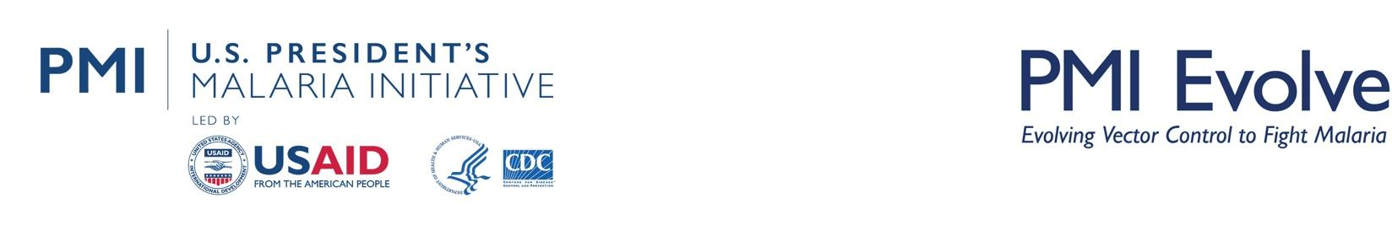
The PMI Evolve Project
Zambia Durability Monitoring Snapshot: 36 Months
November 1 - 11, 2023 (Serenje)
February 12 – 20, 2024 (Nyimba)

Study Overview
Net products:
- Veeralin® (alpha-cypermethrin + PBO)
- Olyset® Plus (permethrin + piperonyl butoxide (PBO)
Design: Different brands in similar zones
Campaign date:
- Serenje: November - December 2020
- Nyimba: January - April 2021
Last data collection round:
- Serenje: 36 months (Nov 1 - 11, 2023)
- Nyimba: 36 months (Feb 12 – 20, 2024)

Study Site Locations Within Zambia
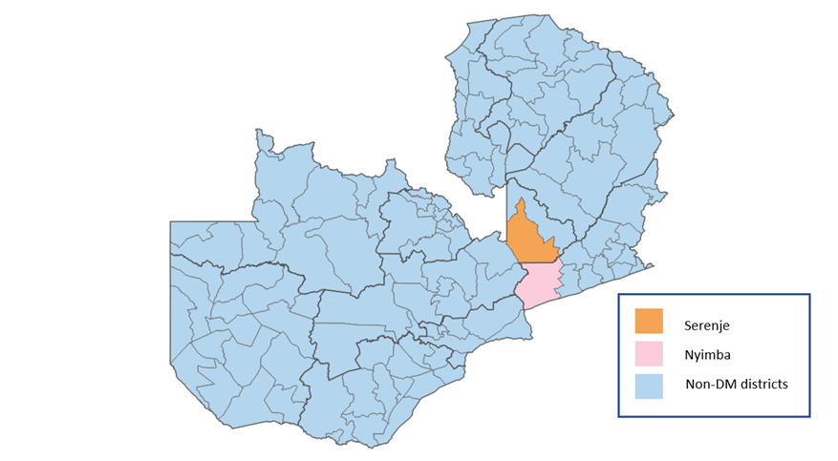

Key Results
ITN attrition was similar in both districts at 36 months (74% in Nyimba and 72% in Serenje), driven primarily by nets being given away to others (49% in Nyimba and 47% in Serenje), and due to wear and tear (discarded) (24% in Nyimba and 23% in Serenje). However, the proportion of cohort nets in serviceable condition was significantly lower in Nyimba compared to Serenje (52% versus 90%; p<0.001). Additionally, the proportion of cohort nets that survived in serviceable condition at 36 months was significantly lower in Nyimba compared to Serenje (26% versus 47%, p=0.015). In Serenje, a significantly higher proportion of cohort ITNs were observed hanging over sleeping spaces (tied or untied) compared to Nyimba (68% versus 48%, p=0.004).
Mean PBO content for Olyset® Plus ITNs was never measured within the manufacturer’s target dose (10 g/kg ±25%) during any study round, including baseline. At endline, mean PBO content was measured at 1.7 g/kg, a reduction of 83% compared to the target dose. Mean PBO content for Veeralin® ITNs fell below the manufacturer’s target dose (2.2 g/kg ±25%) after the 24-month survey round. By study endline, PBO content was measured at 1.0 g/kg, a reduction of 55% compared to the target dose. While 24-hour mortality in field ITN samples was low for both brands at study endline against the resistant strain, (Olyset® Plus: 19%; Veeralin®: 20%), KD60 stayed at 100% across brands and study rounds. While the 24-hour mortality rates for both ITN brands showed a slight increase from the 24-month to the 36-month survey rounds, the overlapping confidence intervals indicate the difference between rounds was not statistically significant.
This is the first completed PMI Evolve-supported durability monitoring study to include Veeralin® ITNs, which precludes comparison of their field performance to other study sites. Olyset® Plus ITNs were studied with PMI Evolve support in Sierra Leone from 2020 to 2023. While reductions in mean PBO content at endline were slightly greater in Zambia (83% compared to 77% in Sierra Leone), 24-hour mortality against the resistant strain was higher in Zambia (19% compared to just 2% in Sierra Leone). In a recently published study in Tanzania, 24-hour mortality for 36-month ITN samples against a resistant strain was 5%.
The WHO recommendations remain for country programs to conditionally prioritize new net types in areas where pyrethroid resistance has been detected. The results from this study should be considered by decision-makers when procuring and deploying ITNs in Zambia.
Site | Survey round and time since distribution (months) | Attrition wear and tear  (%) | Remaining nets in serviceable condition  %(N) | Remaining nets hanging over sleeping space (%) |  | 24– hour mortality against resistant mosquito strain^{γ}  % (95% CI) | Chemical content  g/kg (95% CI)
 |  |  |  | Campaign | Other
Nyimba  (Olyset® Plus) | Baseline: (8.1) | 1.7% | 90.3% (N=236) | 51.7% | 60.8% | 40.1 (32.1-48.1) | 4.5 (3.8-5.1) ª
 | 12m: (13.7) | 5.4% | 78.9% (N=171) | 67.7% | 80.6% | 66.2 (58.6-73.8) | 3.8 (3.1-4.6) ª
 | 24m: (25.2) | 15.2% | 66.7% (N=105) | 72.2% | 87.6% | 12.9 (5.9-20.0) | 2.1 (1.5-2.6) ª
 | 36m: (36.8) | 23.5% | 51.5% (N=68) | 47.8% | 65.6% | 18.8 (10.1-27.4) | 1.7 (1.0-2.4) ª
Serenje  (Veeralin®) | Baseline: (9.4) | 1.7% | 97.2% (N=324) | 61.5% | 56.7% | 34.3 (29.7-38.8) | 1.7 (1.6-1.7) ^{b}
 | 12m: n/a* | n/a* | n/a* | n/a* | n/a* | n/a* | n/a*
 | 24m: (23.1) | 12.7% | 91.8% (N=159) | 59.7% | 62.2% | 11.3 (6.5-16.1) | 1.3 (1.2-1.5) ^{b}
 | 36m: (35.0) | 22.9% | 89.7% (N=97) | 67.9% | 81.0% | 19.8 (9.5-30.1) | 1.0 (0.8-1.2) ^{b}
ª PBO content (manufactured with 10 g/kg in all panels, with an acceptable range of 7.5 g/kg - 12.5 g/kg)
^{b} PBO content (manufactured with 2.2 g/kg in all panels, with an acceptable range of 1.65 g/kg – 2.75 g/kg)
^{γ} Result for 24-hour mortality when tested against the resistant strain using cone bioassays
*The 12-month survey was not conducted in Serenje given the short time that had elapsed between the conclusion of the baseline survey and the planned 12-month survey.

Key Risk Factors for Cohort ITN Physical Durability
- Excessive washing of nets, particularly with cleaning agents such as detergent or bleach, can reduce insecticide effectiveness. Although this practice was widespread in both districts, it was significantly more prevalent in Nyimba (94% versus 79% in Serenje; p=0.031) at 36 months. The use of detergent or bleach was common in both districts (92% in Nyimba versus 83% in Serenje; p=0.1904).
- Hanging nets should be folded or tied when not in use to reduce the risk of damage. Among hanging ITNs, a significantly higher proportion of nets were not folded or tied up in Nyimba compared to Serenje at 36 months (94% in Nyimba, 61% in Serenje; p=0.003).
- Exposure to SBC net care messages, positive attitudes towards nets, and positive net care and repair attitudes have been shown to be determinants associated with increased ITN survival.,, In Nyimba, recall of SBC net care messages was higher compared to Serenje (54% versus 7%; p<0.001), along with positive attitudes towards nets (Nyimba 79% versus Serenje 61%; p=0.027) and positive net care and repair attitudes (Nyimba 74% versus Serenje 44%; p=0.003). Multivariable analysis will be conducted for the manuscript to investigate these and other covariates and their significance in ITN survival in the Zambian context.
- Households are encouraged to repair damaged nets. Households in Nyimba reported significantly more discussions on net care and repair compared to Serenje (40% Nyimba, 19% Serenje; p=0.044). Additionally, a higher proportion of households in Nyimba had ever repaired a net compared to Serenje at 36 months (53% Nyimba, 20% Serenje; p=0.001).

Cohort ITN Survival in Serviceable Condition
The chart illustrates the proportion of nets in serviceable condition over time, comparing actual survival data from baseline, 12-, 24- and 36-month rounds with hypothetical survival curves for nets lasting one to four years. At 36 months, the estimated median useful life for nets in Nyimba (Olyset® Plus) was 2.0 years (95% CI: 1.2-2.5), while ITNs in Serenje (Veeralin®) had a median life of 2.8 years (95% CI: 2.3-3.2). The lower median survival time in Nyimba was likely due to fewer ITNs remaining in serviceable condition and fewer surviving nets compared to Serenje.

Bioassay and Chemical Results: Olyset® Plus ITNs
Olyset® Plus are polyethylene ITNs that combine both permethrin and PBO-synergist on all panels. Cone bioassays were conducted with both pyrethroid-susceptible and -resistant mosquito strains, comparing field ITNs to new Olyset® Plus positive controls, pyrethroid-only Olyset® positive controls and untreated Safi Net® negative controls. KD60 and 24-hour mortality were assessed separately for susceptible and resistant strains. Against both susceptible and resistant strains, field ITNs and both sets of positive controls demonstrated 100% KD60 at study endline. Mortality after 24-hours declined throughout the study for both susceptible and resistant mosquitoes in field samples, although more so against the pyrethroid-resistant strain (Susceptible: 76% at baseline to 33% at endline; Resistant: 40% at baseline to 19% at endline).
Olyset® Plus ITNs are manufactured with 20 g/kg of permethrin and 10 g/kg of PBO on all panels. After 36 months of field use, the mean chemical content of permethrin decreased to 10.2 g/kg, representing a 49% loss compared to the manufacturer target dose. Mean PBO concentration was measured at 1.7 g/kg, corresponding to an 83% loss of chemical content compared to the manufacturer target dose.
24-hour mortality for field Olyset® Plus ITNs taken from Nyimba District, Zambia and control ITNs against resistant An. arabiensis mosquitoes | Permethrin and PBO content from ITNs taken from Nyimba District, Zambia
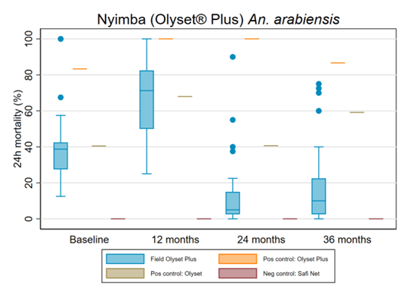  Results from WHO cone bioassays: the box plot shows the median (line), interquartile range (box), adjacent values (whiskers) and outliers (circles). | 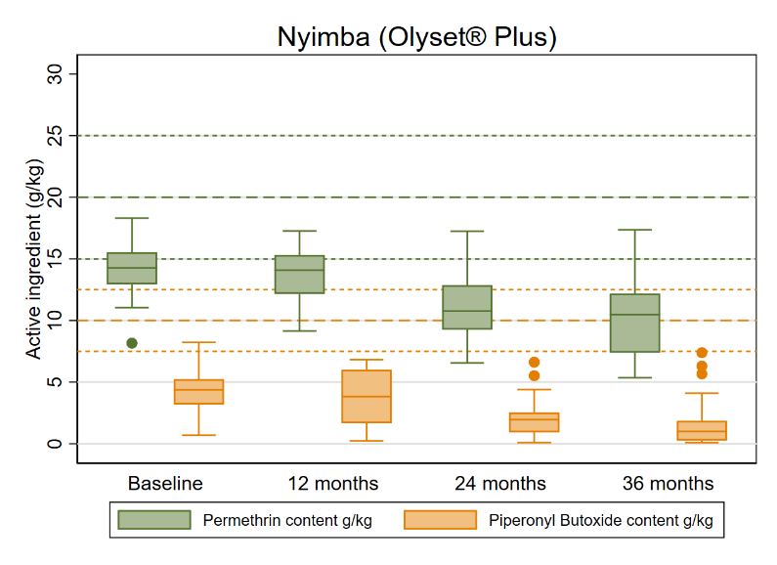  Results from chemical testing: the box plot shows the median (line), interquartile range (box), adjacent values (whiskers) and outliers (circles), dotted lines represent manufacturer target doses for the corresponding insecticide or synergist, with colors aligned to the legend.

Bioassay and Chemical Results: Veeralin® ITNs
Veeralin® are polyethylene ITNs that combine both alpha-cypermethrin and PBO-synergist on all panels. Mosquito strain characterization and cone bioassay testing was conducted in the same manner described on the previous page. Against both susceptible and resistant strains, field ITNs and the unwashed Veeralin® positive control demonstrated 100% KD60 at study endline. For field ITN samples, 24-hour mortality remained high against the susceptible strain but declined significantly against the resistant strain (Susceptible: 99% at baseline to 92% at endline; Resistant: 97% at baseline to 20% at endline).
Veeralin® ITNs are manufactured with 6 g/kg of alpha-cypermethrin and 2.2 g/kg of PBO on all panels. After 36 months of field use, the mean chemical content of alpha-cypermethrin decreased to 4.7 g/kg, representing a 22% loss compared to the manufacturer target dose. Mean PBO concentration was measured at 1.0 g/kg, corresponding to a 55% loss of chemical content compared to the manufacturer target dose.
24-hour mortality for field Veeralin® ITNs taken from Serenje District, Zambia and control ITNs against resistant An. arabiensis mosquitoes | Alpha-cypermethrin and PBO content from ITNs taken from Serenje District, Zambia
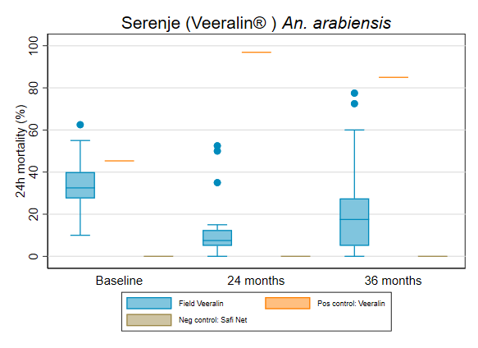  Results from WHO cone bioassays: the box plot shows the median (line), interquartile range (box), adjacent values (whiskers) and outliers (circles). | 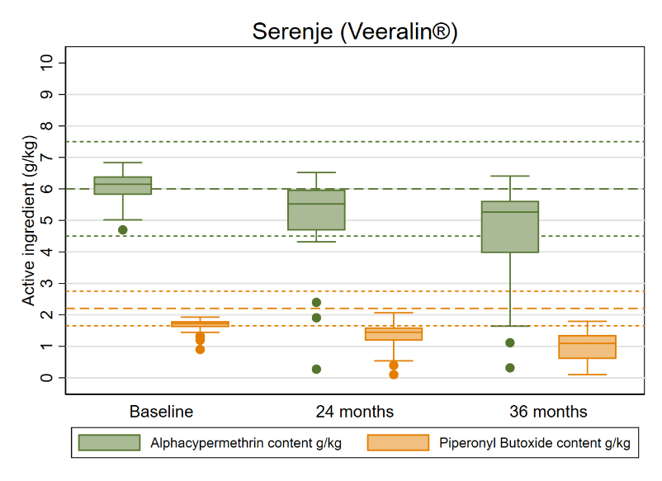  Results from chemical testing: the box plot shows the median (line), interquartile range (box), adjacent values (whiskers) and outliers (circles), dotted lines represent manufacturer target doses for the corresponding insecticide or synergist, with colors aligned to the legend.

Durability Monitoring Indicator Definitions
Attrition due to wear and tear: The percentage of cohort nets lost due to being destroyed, discarded, or used for other purposes out of all cohort nets received by sampled households. This does not include nets that were given away, sold, or stolen.
à Provides an estimate of the attrition relevant to estimation of the physical durability in contrast to “all cause attrition” which includes also nets given away etc. Attrition due to wear and tear is correlated with the median survival of the cohort nets.
Remaining nets in serviceable condition: The percentage of cohort nets surviving to date that are still in serviceable physical condition (good or damaged), specifically, with a proportionate hole index of 642 or less.
à Provides an estimate of the physical quality of remaining campaign nets.
Remaining nets hanging over sleeping space: The percentage of cohort nets and, separately, non-cohort nets present in the household that are hanging up, whether tied up or not.
à Provides an estimate of the use of different nets in the household. Households adopt nets newly received from campaigns at different rates. A present net hanging up in the home is an indicator of net use generally, beyond the formal indicator of net use the night before the survey.
Optimal insecticidal effectiveness: The percentage of sampled campaign nets that have at least 95% KD60 or 80% mortality in the WHO cone bioassay. Alternatively, 90% feeding inhibition or 80% mortality in the tunnel test.
à Provides an estimate of the effectiveness of the insecticide found on mass campaign LLIN at each period of follow-up.
Cohort survival in serviceable condition: The proportion of all cohort nets sampled at baseline that are in serviceable physical condition at each period of follow-up out of all cohort nets with a known outcome (excluding nets given away to others, stolen, or sold).
à Provides an estimate of the proportion of all campaign nets that are still able to effectively protect the population from malaria when slept under.

PMI-VectorLink-Sierra-Leone-36-Month-DM-Snapshot-with-Bioassays-and-Chemical-Results
Salum Azizi et al., “Evaluation of Durability as a Function of Fabric Strength and Residual Bio-Efficacy for the Olyset Plus and Interceptor G2 LLINs after 3 Years of Field Use in Tanzania,” Tropical Medicine and Infectious Disease 8, no. 8 (July 25, 2023): 379, https://doi.org/10.3390/tropicalmed8080379.
WHO publishes recommendations on two new types of insecticide-treated nets
Kilian A, Obi E, Mansiangi P, Abílio AP, Haji KA, Blaufuss S, et al. Variation of physical durability between LLIN products and net use environments: summary of findings from four African countries. Malar J. 2021 Jan 7;20(1):26.
Haji KA, Khatib BO, Obi E, Dimoso K, Koenker H, Babalola S, et al. Monitoring the durability of the long-lasting insecticidal nets Olyset® and PermaNet® 2.0 in similar use environments in Zanzibar. Malar J. 2020 May 24;19(1):187.
Mansiangi P, Umesumbu S, Etewa I, Zandibeni J, Bafwa N, Blaufuss S, et al. Comparing the durability of the long-lasting insecticidal nets DawaPlus® 2.0 and DuraNet© in northwest Democratic Republic of Congo. Malar J. 2020 May 24;19(1):189.
Prior to bioassays, the Anopheles (An.) gambiae s.s. strain was confirmed to be pyrethroid-susceptible and the An. arabiensis strain, pyrethroid-resistant using WHO susceptibility test and molecular characterization of insecticide resistance markers.

