A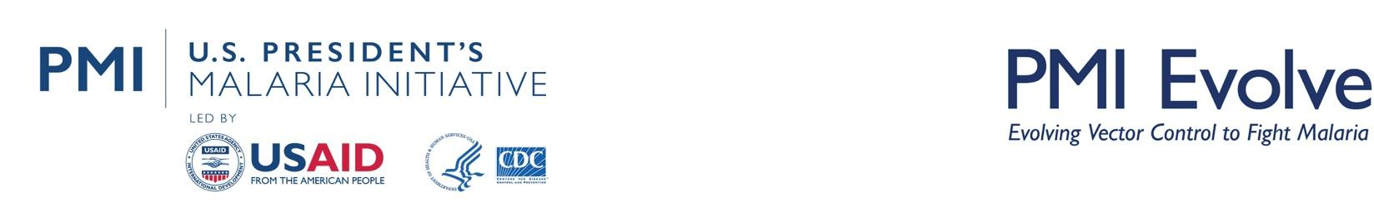

The PMI Evolve Project
Côte d’Ivoire Durability Monitoring Snapshot: 36-months
March 18-27, 2024

Study Overview
Net products:
- PermaNet® 3.0 (deltamethrin + piperonyl butoxide (PBO))
- Interceptor® G2 (alpha-cypermethrin + chlorfenapyr)
Design: Two brands in similar zones
Campaign date: April 25-29, 2021
Last data collection round: 36 months (March 18-27, 2024)

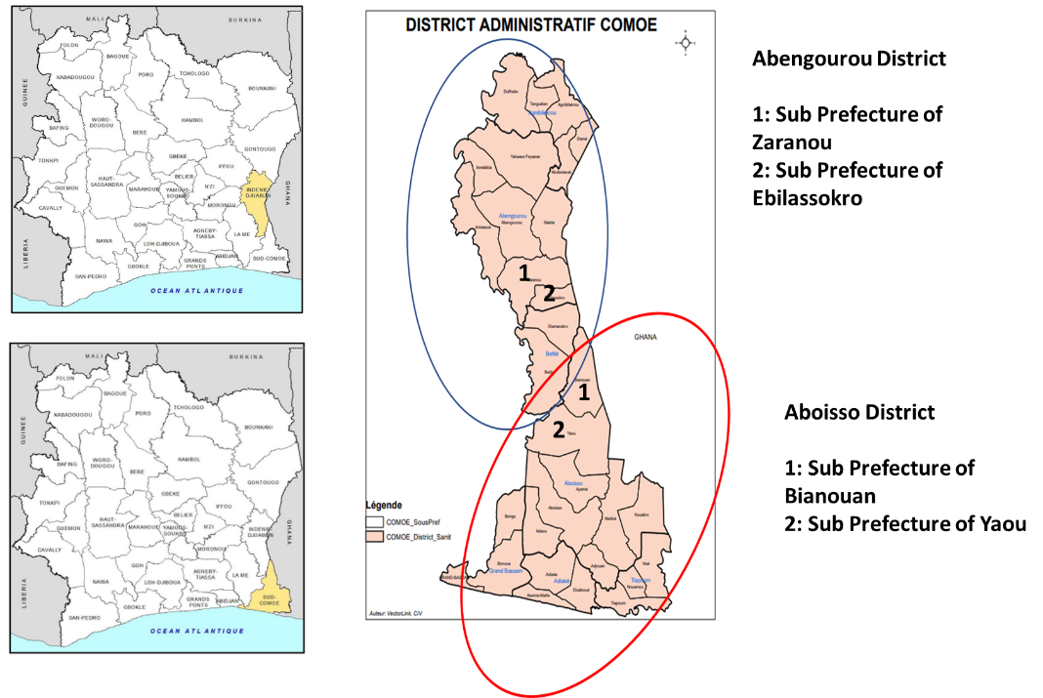
Study Site Locations Within Cote d’Ivoire

Key Results
At study endline, the proportion of cohort nets remaining and in serviceable condition was high across both study sites, although it was marginally but significantly higher in Abengourou (98%) than Aboisso (91%, p=0.011) (Table 1). In both study sites, attrition due to wear and tear remained low (8% in Abengourou and 11% in Aboisso). Generally, the proportion of cohort nets hanging over sleeping spaces (tied or untied) improved from 29% to 49% in Abengourou and from 25% to 59% in Aboisso between baseline and 36-month survey rounds, likely due in part to improved recall of net hanging messaging during 12- and 24-month rounds (78-89% in Abengourou and 11-21% in Aboisso).
The high proportion of cohort nets remaining in serviceable condition and the low rates of attrition due to wear and tear in study districts was likely influenced in part by data collection timing (i.e. lower transmission season) and study site location (semi-urban areas). Not shown in the table below, but relevant to this study, is that the proportion of cohort nets reported as ever-used by study endline was low (66% in Abengourou and 59% in Aboisso), and the average ITN use:access ratio across survey rounds was very low (0.51 in Abengourou and 0.45 in Aboisso). Furthermore, for the same PermaNet® 3.0 ITNs deployed in other countries, the results revealed that a higher proportion of nets ever-used resulted in a decrease in net surviving in a serviceable condition at the endline round.
Across sub-Saharan Africa, net use in those with access varies seasonally. Except for the baseline round, data collection occurred each year in March and/or April. Net use during this period has been shown to be lower than during the average malaria transmission season (May-December). Additionally, use:access was lower in urban areas and generally low in Comoe District (0.72)., Both study sites were in semi-urban sub-prefectures in Comoe, which may have also contributed to low observed use:access, and thus, minimized physical damage to cohort ITNs.
-. Both ITN brands were highly effective in neutralizing pyrethroid-susceptible mosquitoes after 36 months of field use, with mortality rates exceeding 99%. Both brands offered additional protection against resistant mosquitoes. At endline, 24-hour mortality of PermaNet® 3.0 roof panels from Abengourou was 12%, while 72-hour mortality of Interceptor® G2 samples from Aboisso remained stable across survey rounds (between 63% to 66%). Tunnel test blood-feeding inhibition (BFI) for Interceptor® G2 decreased from 74% at baseline to 43% at endline. Mean PermaNet® 3.0 PBO content reduced by 73%. Mean Interceptor® G2 chlorfenapyr content, which was at the low end of the manufacturer’s acceptable range at baseline, decreased by 68% against the manufacturer target dose after 36-months of field use. Observed PermaNet® 3.0 mortality and chemical content reduction trends aligned with those of PMI VectorLink’s durability monitoring study in Burkina Faso, Rwanda, and Sierra Leone. Interceptor® G2 BFI results from this assessment were similar to those seen in a Benin DM study.
Table 1: Physical Durability & Bioassay Analysis
Site | Survey round and time since distribution (months) | Attrition wear and tear  (%) | Remaining nets in serviceable condition | Remaining nets hanging over sleeping space (%) |  | 24/72 – hour mortality against resistant mosquito strain^{β}  % (95% CI) | Chemical content^{β}
 |  |  | %(N) | Campaign | Other |  | N (95% CI)
Abengourou  (PermaNet® 3.0) | Baseline (5.6) | 0.0% | 99.6% (N=258) | 29.1% | 55.5% | 52.3ª (35.6-69.1) | 14.91 (13.55-16.26)^{c}
 | 12m (11.3) | 1.5% | 98.0% (N=245) | 44.7% | 83.3% | 54.0ª (38.8-69.2) | 12.03 (11.09-12.97)^{c}
 | 24m (23.7) | 4.1% | 97.8% (N=178) | 51.7% | 44.6% | 45.7ª (26.9-64.4) | 6.24 (5.25-7.23)^{c}
 | 36m (34.7) | 7.5% | 97.8% (N=136) | 49.2% | 35.4% | 12.0ª (3.0-21.0) | 6.81 (5.25-8.37)^{c}
Aboisso  (Interceptor® G2) | Baseline (5.6) | 0.3% | 98.4% (N=312) | 24.7% | 77.8% | 63.1^{b} (53.1-73.1) | 3.78 (3.44-4.12)^{d}
 | 12m (11.3) | 1.1% | 99.0% (N=291) | 36.6% | 87.6% | 63.7^{b} (59.3-68.2) | 2.61 (2.01-3.21)^{d}
 | 24m (23.7) | 7.0% | 94.2% (N=191) | 54.4% | 66.6% | 58.3^{b} (50.1-66.4) | 1.53 (1.09-1.98)^{d}
 | 36m (34.7) | 10.6% | 90.6% (N=138) | 58.6% | 81.3% | 66.0^{b} (63.7-68.3) | 1.52 (1.01-2.04)^{d}
ª: Result for 24-hour mortality when tested against the resistant strain on the PBO roof panel using cone bioassays.
^{b}: Result for 72-hour mortality when tested against the resistant strain using tunnel tests.
^{c}: PBO content (manufactured with 4 g/kg on roof panel. Acceptable range of 3 g/kg – 5 g/kg).
^{d}: Chlorfenapyr content (manufactured with 4.8 g/kg on all panels. Acceptable range of 3.6 g/kg – 6 g/kg.).

Key Risk Factors for Cohort ITN Physical Durability
- As was highlighted in the 2021 ITN Use Access Report – Cote d’Ivoire, a seasonal analysis of ITN use would be useful to effectively develop and accurately target SBC messaging, especially outside of the high malaria transmission season.
- Very few respondents received exposure to net messaging in the six months preceding the 36-month survey round (5% in Abengourou and 4% in Aboisso). While a comparatively high proportion of respondents reported favorable attitudes towards nets generally (50% in Abengourou and 43% in Aboisso), very few respondents reported favorable attitudes toward net care and repair (8% in Abengourou and 15% in Aboisso).
- Use of detergents and bleach during net washing can reduce the physical and chemical durability of an ITN. In both study sites, a high proportion of ITNs were washed with detergent or bleach at last wash (53% in Abengourou and 68% in Aboisso).
- Rodents may cause damage to ITNs. While only 5% and 10% of respondents in Abengourou and Aboisso reported seeing rodents preceding the endline survey round, respectively, efforts should be made to ensure rodents remain away from sleeping areas. One way to deter rodents from sleeping areas is to avoid storing food there, a practice which was more common in Abengourou (48%) than Aboisso (19%; p=0.019).

Cohort ITN Survival in Serviceable Condition
To accurately calculate estimated median useful life, the percentage of all cohort nets surviving in serviceable condition must be measured at below 85% for at least two survey rounds. Even at study endline, 85.8% (95 CI: 77.8% – 93.1%) of cohort ITNs in Abengourou survived in serviceable condition. Therefore, estimated median useful life for PermaNet® 3.0 ITNs could not be calculated in that location.
At the 24-month survey round, 84.5% (95% CI: 75.3% - 90.7%) of Interceptor® G2 ITNs in Aboisso survived in serviceable condition, which decreased to 73.1% (95% CI: 62.1% - 81.8%) by study endline. The below chart plots the proportion of Interceptor® G2 ITNs surviving in serviceable condition against hypothetical survival curves for nets lasting one to four years using the survival data from baseline, 12-, 24-, and 36-month survey rounds. The estimated median useful life of Interceptor® G2 ITNs in Aboisso was 4.8 years (95% CI: 3.7-6.2). While the percentage of surviving nets in serviceable condition was technically below 85% for two survey rounds, estimated median useful life should be interpreted with caution, as the 24-month survival in serviceable condition point estimate bordered the 85% threshold, with the upper bound of the confidence interval above the threshold.
Aboisso median survival: 4.8 years

Bioassay and Chemical Results: PermaNet® 3.0 Brand ITNs
The PermaNet® 3.0 brand is a pyrethroid + PBO synergist ITN with deltamethrin-only on the net sides and deltamethrin + PBO on the roof. Susceptibility test data confirmed resistance of wild strain An. gambiae s.l. to deltamethrin 0.05%, with 24-hour mortality at 6%. Pre-exposure to PBO synergist before deltamethrin showed a 78% increase in mortality compared to deltamethrin alone. At 36 months, 24-hour mortality of PermaNet® 3.0 field-collected ITN roof samples against the pyrethroid-resistant An. gambiae s.l. colony dropped to 12%, substantially lower than rates recorded from baseline to 24 months (52-46%). Low mortality is likely attributed to the 73% reduction in mean PBO chemical content on roof samples (6.81 g/kg), compared to the manufacturer's target dose of 25 g/kg at endline. Mean roof deltamethrin content was 3.87 g/kg, which was within the 25% manufacturer buffer. Mortality after 24-hours for field side panels, which do not incorporate PBO, remained low across survey rounds. Mean side panel deltamethrin was measured at 0.87 g/kg at 36 months, a 59% reduction compared to the manufacturer’s target dose of 2.1 g/kg.
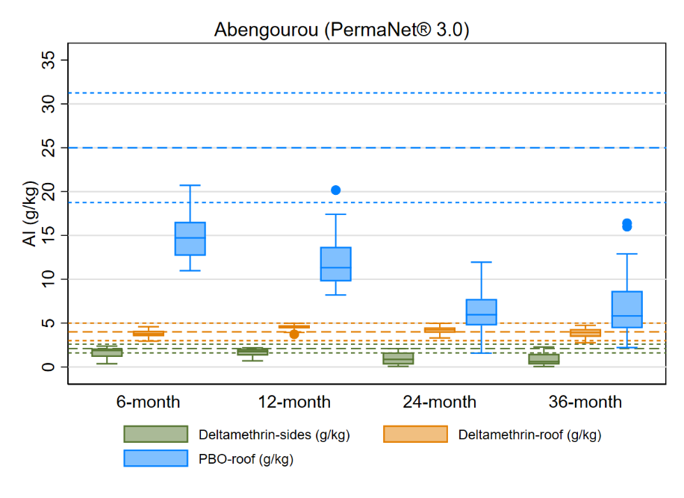
Side/roof deltamethrin content and roof PBO content from Abengourou District, Cote d’Ivoire
24-hour mortality for field/new PermaNet® 3.0 brand side and roof ITNs taken from Abengourou District, Cote d’Ivoire against resistant An. gambiae s.l. mosquitos
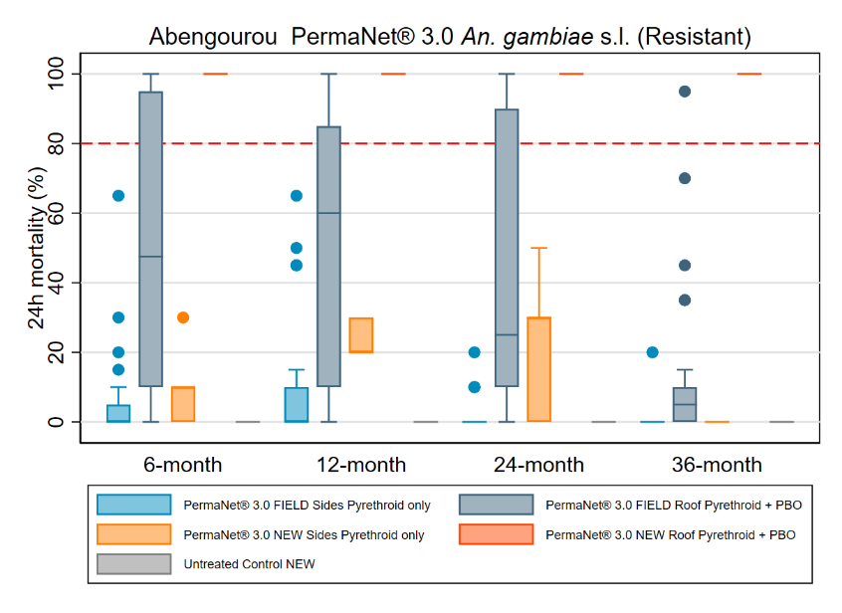
Box plot shows the median (horizontal line), interquartile range (box), adjacent values (whiskers), outliers (circles), and for each legend, bold line dashes specify manufacturer threshold (with fine line dashes indicating acceptable range).
Box plot shows the median (horizontal line), interquartile range (box), adjacent values (whiskers), outliers (circles), and for each legend, red dashed line represents WHO optimal effectiveness thresholds for mortality 80%.

Bioassay and Chemical Results: Interceptor® G2 Brand ITNs
The Interceptor® G2 brand is an alpha-cypermethrin + cholrfenapyr ITN on all sides. Susceptibility test data confirmed resistance of wild strain An. gambiae s.l. to alpha-cypermethrin. Pre-exposure to PBO synergist before alpha-cypermethrin showed a 94% increase in 24-hour mortality compared to alpha-cypermethrin alone. At 36 months, mean alpha-cypermethrin content was 1.52 g/kg, corresponding to a loss of 37% compared to the manufacturer’s target dose of 2.4 g/kg. Mean chlorfenapyr content was 1.52 g/kg, a reduction of 68% compared to the manufacturer’s target dose of 4.8 g/kg. Losses of alpha-cypermethrin and chlorfenapyr across survey rounds did not appear to affect 72-hour mortality, which remained similar across rounds. However, the blood feeding inhibition appeared to be impacted, dropping from 74% at baseline to 43% at the 36-month timepoint.
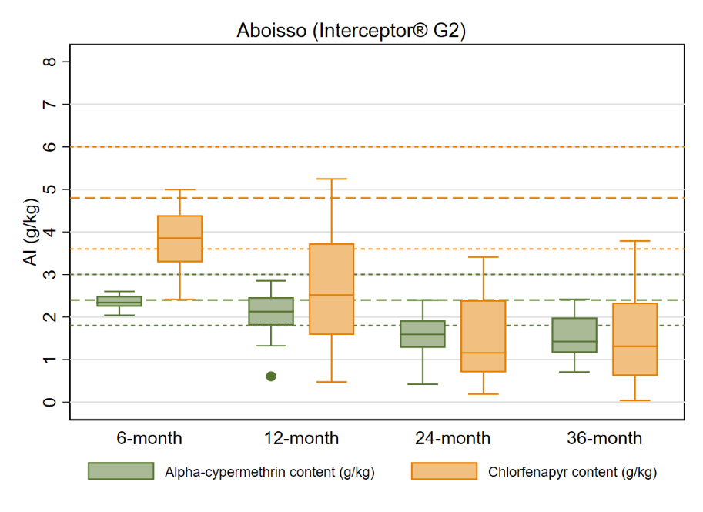
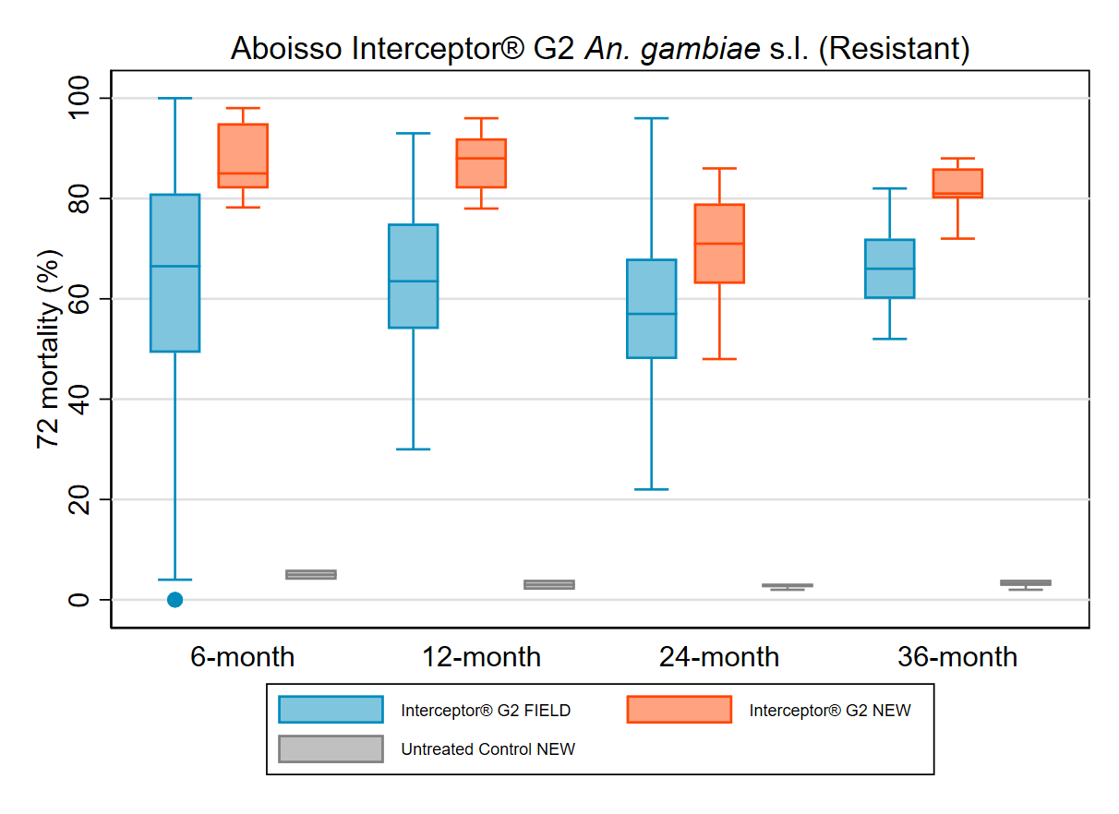
Alpha-cypermethrin and chlorfenapyr content of Interceptor® G2 brand ITNs from Aboisso District, Cote d’Ivoire
72-hour mortality for field/new Interceptor® G2 ITN brand samples taken from Aboisso District, Cote d’Ivoire against resistant An. gambiae s.l. mosquitos
Box plot shows the median (horizontal line), interquartile range (box), adjacent values (whiskers), outliers (circles), and for each legend, bold line dashes specify manufacturer threshold (with fine line dashes indicating acceptable range).
Box plot shows the median (horizontal line), interquartile range (box), adjacent values (whiskers) and outlier (circle).

Durability Monitoring Indicator Definitions
Attrition due to wear and tear: The percentage of cohort nets lost due to being destroyed, discarded or used for other purposes out of all cohort nets received by sampled households. This does not include nets that were given away, sold, or stolen.
à Provides an estimate of the attrition relevant to estimation of the physical durability in contrast to “all cause attrition” which includes also nets given away etc. Attrition due to wear and tear is correlated with the median survival of the cohort nets.
Remaining nets in serviceable condition: The percentage of cohort nets surviving to date that are still in serviceable physical condition (good or damaged), specifically, with a proportionate hole index of 642 or less.
à Provides an estimate of the physical quality of remaining campaign nets.
Remaining nets hanging over sleeping space: The percentage of cohort nets and, separately, non-cohort nets present in the household that are hanging up, whether tied up or not.
à Provides an estimate of the use of different nets in the household. Households adopt nets newly received from campaigns at different rates. A present net hanging up in the home is an indicator of net use generally, beyond the formal indicator of net use the night before the survey.
Optimal insecticidal effectiveness: The percentage of sampled campaign nets that have at least 95% 60-minute knock-down or 80% mortality in the WHO cone bioassay. Alternatively, 90% feeding inhibition or 80% mortality in the tunnel test.
à Provides an estimate of the effectiveness of the insecticide found on mass campaign LLIN at each period of follow-up.
Cohort survival in serviceable condition: The proportion of all cohort nets sampled at baseline that are in serviceable physical condition at each period of follow-up out of all cohort nets with a known outcome (excluding nets given away to others, stolen or sold).
à Provides an estimate of the proportion of all campaign nets that are still able to effectively protect the population from malaria when slept under.

PMI VectorLink Burkina Faso and Sierra Leone Endline Durability Monitoring Study Reports. Available at: www.durabilitymonitoring.org.
Koenker, Hannah, Cameron Taylor, Clara R. Burgert-Brucker, Julie Thwing, Tom Fish, and Albert Kilian. “Quantifying Seasonal Variation in Insecticide-Treated Net Use among Those with Access.” The American Journal of Tropical Medicine and Hygiene 101, no. 2 (August 7, 2019): 371–82. https://doi.org/10.4269/ajtmh.19-0249.
USAID Breakthrough ACTION. ITN Use Access Report – Cote d’Ivoire. 2021. Johns Hopkins Center for Communication Programs. Available at: Côte d’Ivoire (breakthroughactionandresearch.org).
Ibid
Institut National de la Statistique and ICF. 2023. Côte d’Ivoire Enquête Démographique et de Santé 2021 Rapport final. Rockville, Maryland, USA et la Côte d’Ivoire: INS et ICF. Available at https://www.dhsprogram.com/pubs/pdf/FR385/FR385.pdf.
Raharinjatovo, J., Dabiré, R.K., Esch, K. et al. Physical and insecticidal durability of Interceptor®, Interceptor® G2, and PermaNet® 3.0 insecticide-treated nets in Burkina Faso: results of durability monitoring in three sites from 2019 to 2022. Malar J 23, 173 (2024). https://doi.org/10.1186/s12936-024-04989-w
Manuscript not yet published. From baseline to the 36-month timepoint, the 24-hour mortality rate of PermaNet® 3.0 on the roof panel dropped from 99% to 48%, while the PBO chemical content reduced from 15 g/kg to 5 g/kg. PMI-Evolve-Rwanda-36M-ITN-DM-Report-APPROVED.docx (live.com)
Manuscript not yet published. From baseline to the 36-month timepoint, the 24-hour mortality rate of PermaNet® 3.0 on the roof panel dropped from 48% to 13%, while the PBO chemical content reduced from 16 g/kg to 13 g/kg. PMI-VectorLink-Sierra-Leone-36-Month-DM-Snapshot-with-Bioassays-and-Chemical-Results-clean.docx (live.com)
Azizi S, Martin J, Mbewe NJ, Msapalla A, Mwacha S, Joram A, Mawa B, Kaaya RD, Kitau J, Mosha F, Matowo J, Protopopoff N. Evaluation of Durability as a Function of Fabric Strength and Residual Bio-Efficacy for the Olyset Plus and Interceptor G2 LLINs after 3 Years of Field Use in Tanzania. Trop Med Infect Dis. 2023 Jul 25;8(8):379. doi: 10.3390/tropicalmed8080379. PMID: 37624317; PMCID: PMC10459516.
Ahogni, I.B., Salako, A.S., Akinro, B. et al. Physical integrity and survivorship of long-lasting insecticidal nets distributed to households of the same socio-cultural community in Benin, West Africa. Malar J 19, 58 (2020). https://doi.org/10.1186/s12936-020-3138-7
PMI Evolve Project. Durability Monitoring Toolkit: English (Barcodes). Available at: Tools | LLIN Durability Monitoring
The high percentage of cohort ITNs surviving in serviceable condition was driven by a low percentage of ever-hung cohort ITNs at study endline (56% in Aboisso and 61% in Abengourou).

